**COMSATS UNIVERSITY ISLAMABAD**



**SUBMITTED BY**

|  |  |
| --- | --- |
| **NAME** | **ENROLLMENT** |
| AYESHA HASSAN | FA19-BSE-110 |
| NOOR UL AIN | FA19-BSE-168 |

**SECTION:** BSE-7C

**SUBMITTED TO**

**TEACHER:** Ms. MAMUNA FATIMA

**SUBJECT:** DATA WAREHOUSING & DATA MINING

**ASSIGNMENT # 01**

**Table of Contents**

1. Select 3

2. Insert 4

3. Update 4

4. Delete 5

5. Distinct 6

6. Where clause 6

7. AND/OR 6

8. IN 7

9. ALIAS 7

10. BETWEEN 7

11. LIKE 8

12. COUNT, SUM, MIN, MAX 8

13. ORDER BY 9

14. GROUP BY 9

15. HAVING 9

16. INNER JOIN 10

17. LEFT JOIN 10

18. LEFT OUTER JOIN 11

19. RIGHT OUTER JOIN 11

20. SELF JOIN 11

21. CREATE VIEW 12

22. AVG 12

23. SQL STRING FUNCTIONS 12

24. SQL UNION 14

**SQL QUERIES**

**QUESTION:**

The purpose of this assignment is to understand following SQL queries syntax and the purpose. You have to make a database of your choice in SQL Server or any other DBMS and run the following SQL queries on it. The output of this assignment is a document containing the SQL queries plus the screen shots of the output tables.

Additional points will be given to those groups who will make GUI along with as well.

## Select

# [SELECT](http://localhost:8012/phpmyadmin/url.php?url=https://dev.mysql.com/doc/refman/8.0/en/select.html) * FROM `donor`

## Insert

[INSERT](http://localhost/phpmyadmin/url.php?url=https://dev.mysql.com/doc/refman/8.0/en/insert.html) INTO `donor` (`Name`, `address`, `email`, `phoneNumber`, `DOB`, `bloodGroup`,`password`) [VALUES](http://localhost/phpmyadmin/url.php?url=https://dev.mysql.com/doc/refman/8.0/en/miscellaneous-functions.html#function_values) ('Noor', 'House#72, islamabad', 'noor223@gmail.com', 307564321, '2001-09-26', 'AB-','N143'),

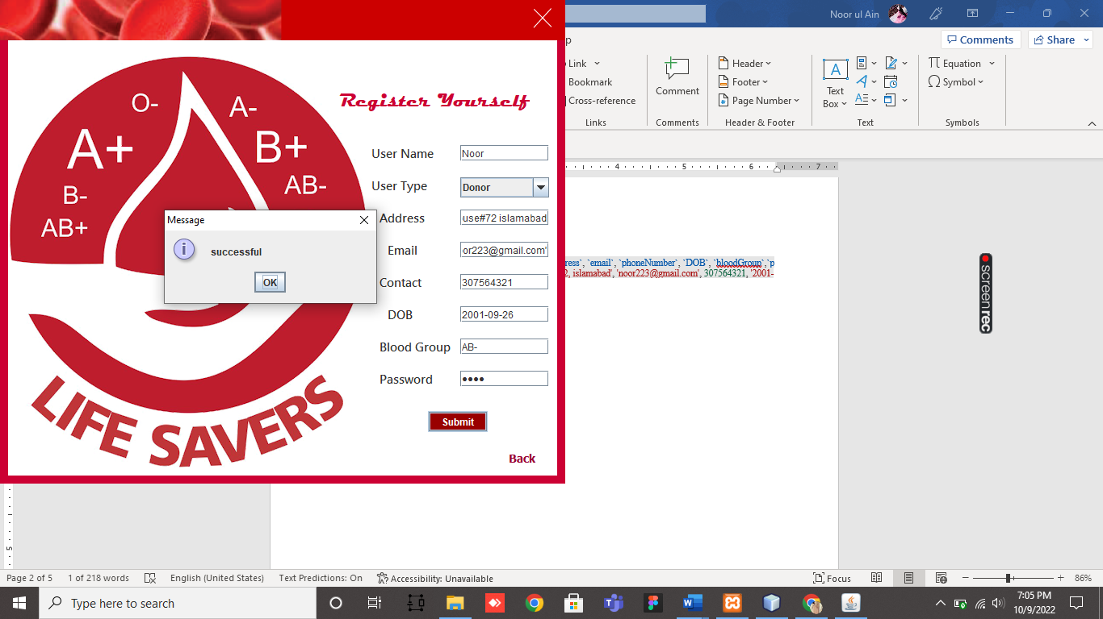

## Update

[UPDATE](http://localhost:8012/phpmyadmin/url.php?url=https://dev.mysql.com/doc/refman/8.0/en/update.html) donor [SET](http://localhost:8012/phpmyadmin/url.php?url=https://dev.mysql.com/doc/refman/8.0/en/set.html) Name = 'Noor' WHERE donor_ID=9

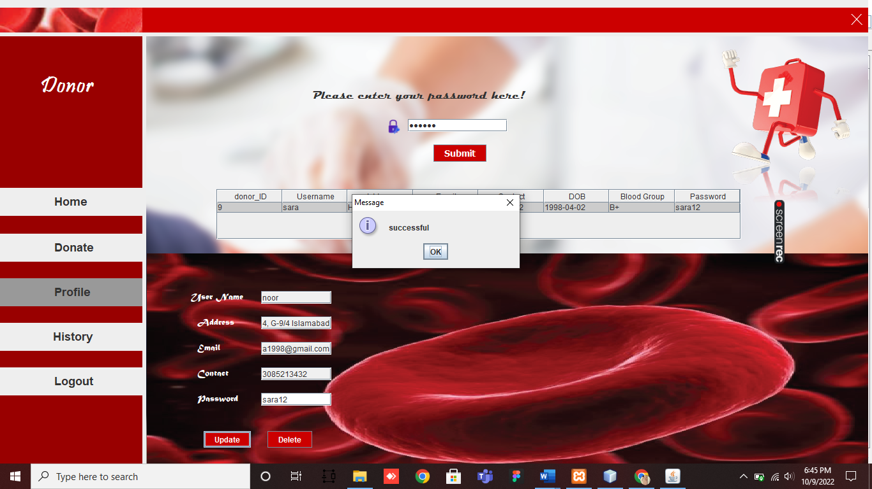

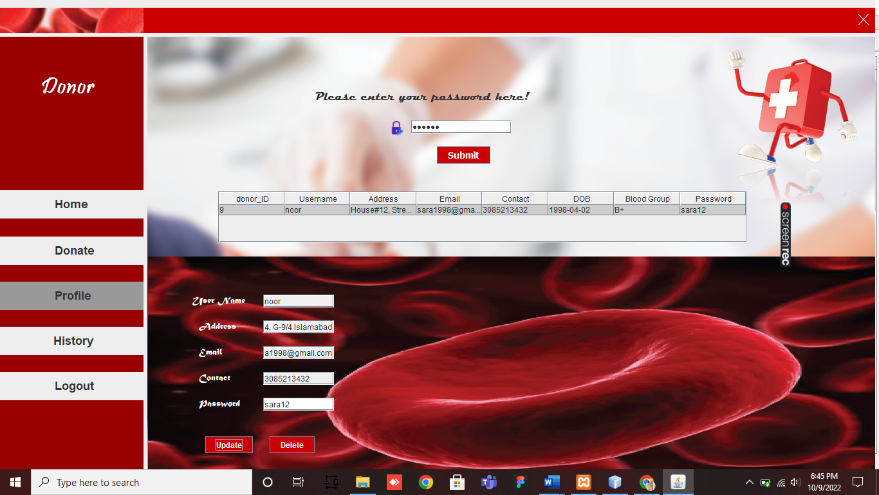

## Delete

[DELETE](http://localhost:8012/phpmyadmin/url.php?url=https://dev.mysql.com/doc/refman/8.0/en/delete.html) FROM donor WHERE [password](http://localhost:8012/phpmyadmin/url.php?url=https://dev.mysql.com/doc/refman/8.0/en/encryption-functions.html#function_password)='sara12'

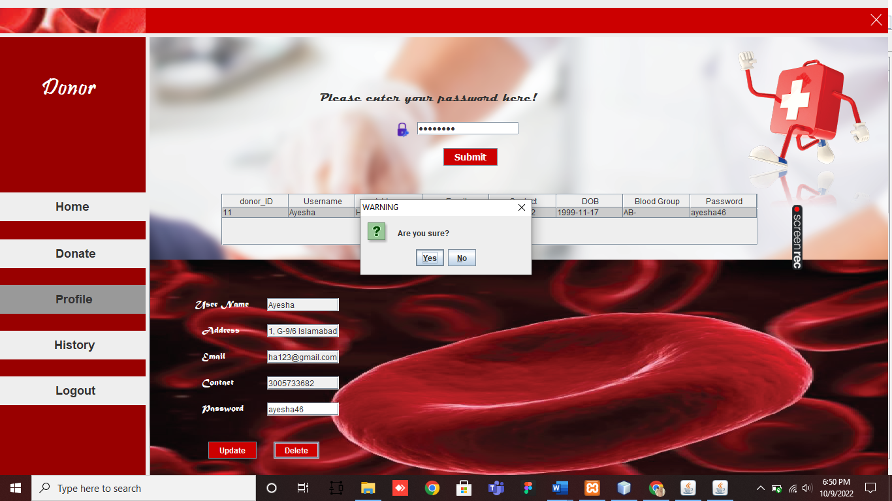

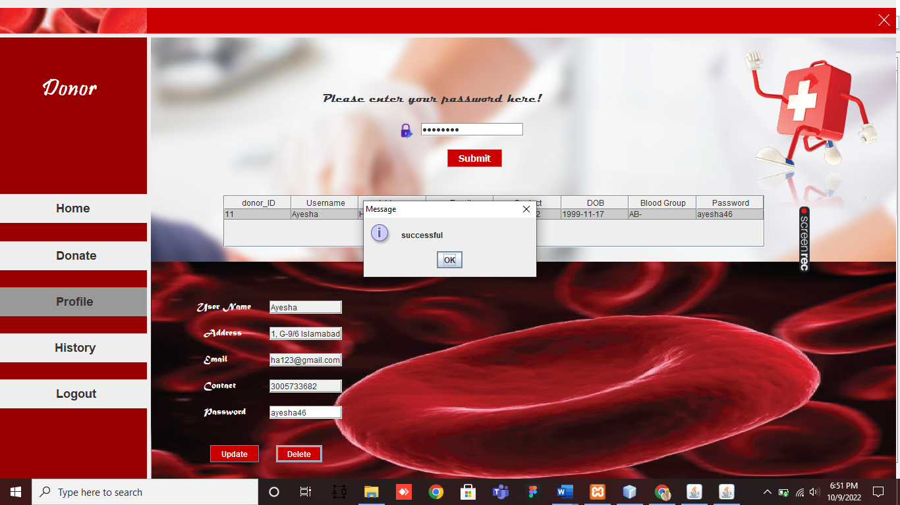

## Distinct

[SELECT](http://localhost/phpmyadmin/url.php?url=https://dev.mysql.com/doc/refman/8.0/en/select.html) [COUNT](http://localhost/phpmyadmin/url.php?url=https://dev.mysql.com/doc/refman/8.0/en/group-by-functions.html#function_count)(DISTINCT `id`) FROM booking

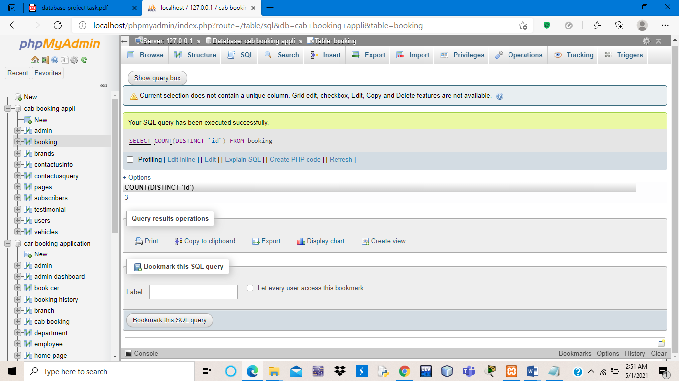

## Where clause

[SELECT](http://localhost:8012/phpmyadmin/url.php?url=https://dev.mysql.com/doc/refman/8.0/en/select.html) * FROM `blooddonation` WHERE `bloodGroup`='O-'

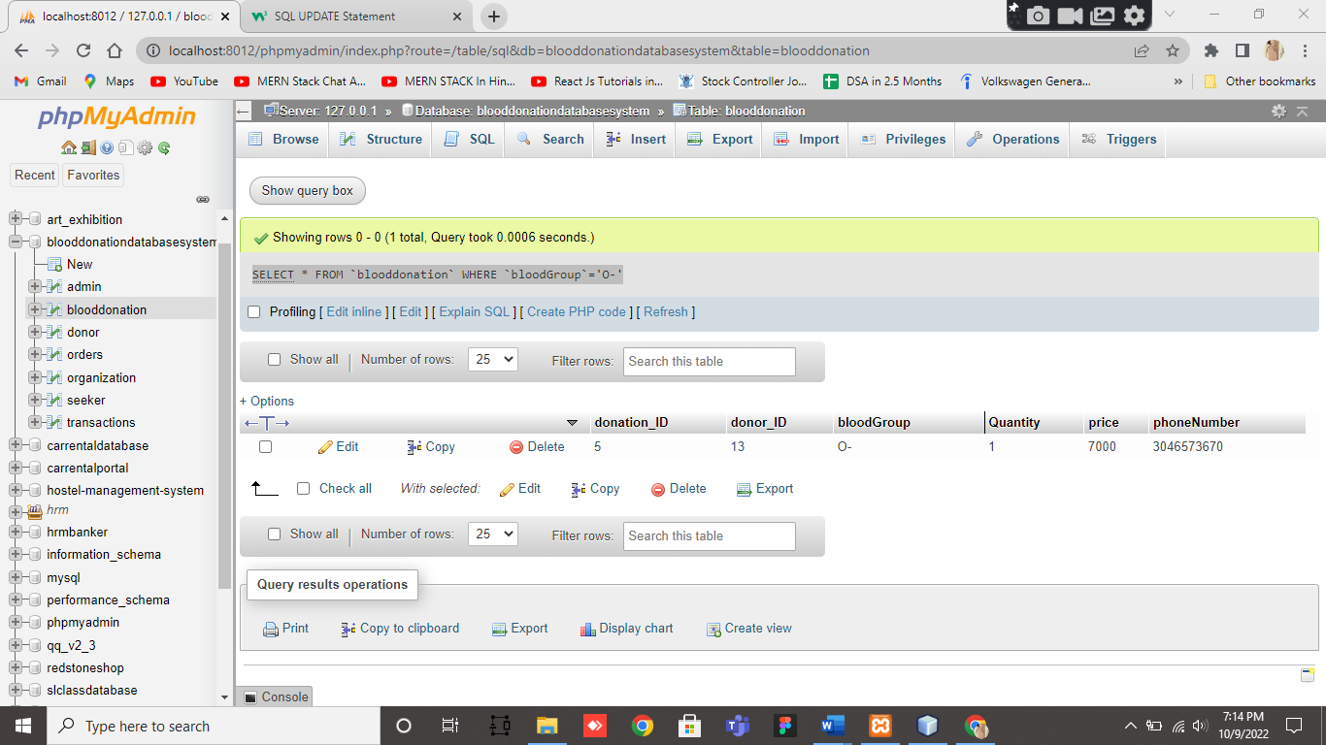

## AND/OR

[SELECT](http://localhost:8012/phpmyadmin/url.php?url=https://dev.mysql.com/doc/refman/8.0/en/select.html) * FROM seeker WHERE bloodGroup='AB-' [AND](http://localhost:8012/phpmyadmin/url.php?url=https://dev.mysql.com/doc/refman/8.0/en/logical-operators.html#operator_and) Name='Mahnoor'

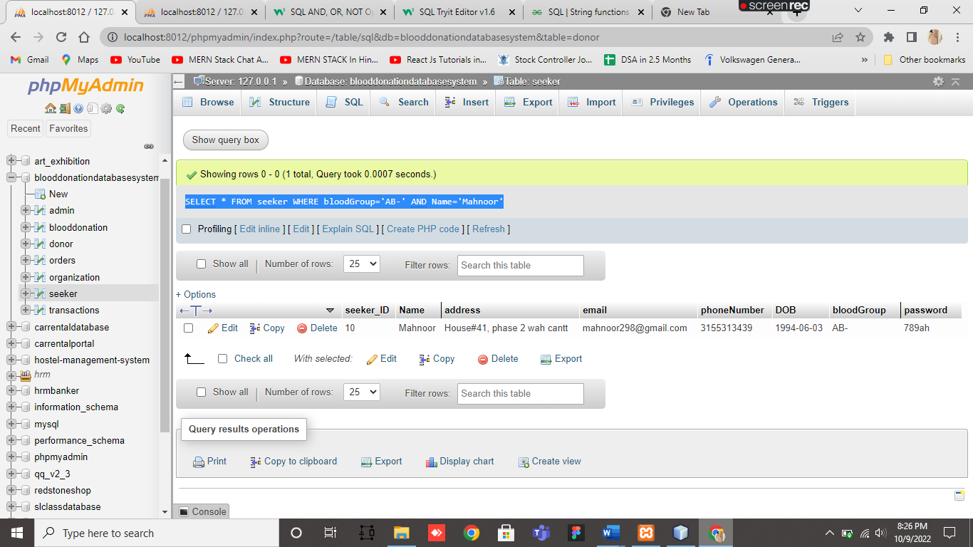

[SELECT](http://localhost:8012/phpmyadmin/url.php?url=https://dev.mysql.com/doc/refman/8.0/en/select.html) * FROM seeker WHERE bloodGroup='O+' [OR](http://localhost:8012/phpmyadmin/url.php?url=https://dev.mysql.com/doc/refman/8.0/en/logical-operators.html#operator_or) bloodGroup='O-'

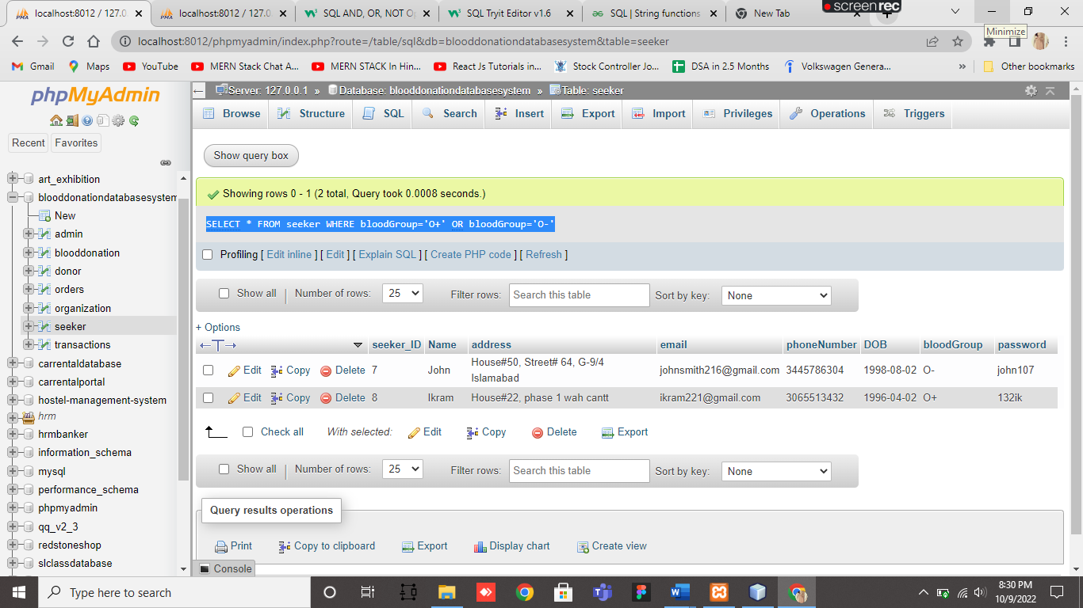

## IN

[SELECT](http://localhost/phpmyadmin/url.php?url=https://dev.mysql.com/doc/refman/8.0/en/select.html) `id`, `BrandName` FROM `brands` WHERE `BrandName` [IN](http://localhost/phpmyadmin/url.php?url=https://dev.mysql.com/doc/refman/8.0/en/comparison-operators.html#function_in)('Maruti')

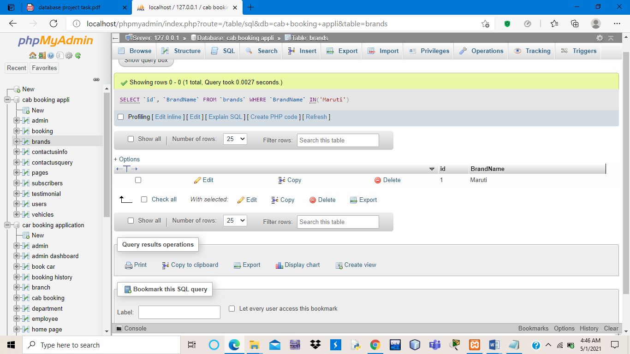

## ALIAS

[SELECT](http://localhost:8012/phpmyadmin/url.php?url=https://dev.mysql.com/doc/refman/8.0/en/select.html) donor_ID AS ID, Name AS Donar_Name FROM donor

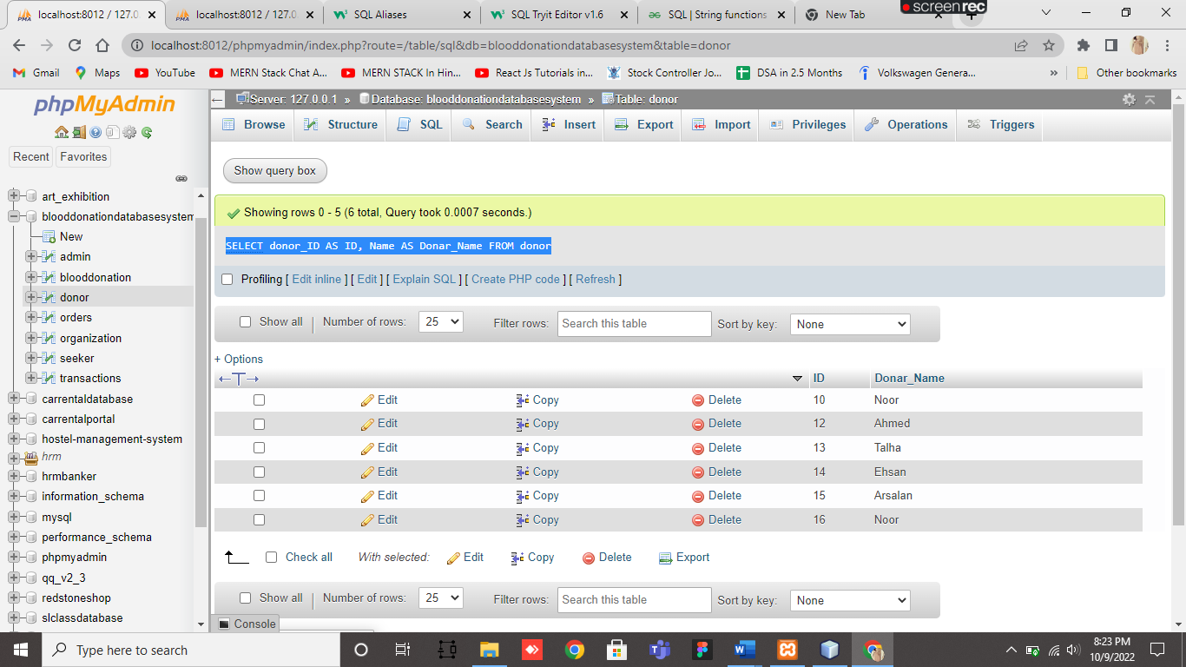

## BETWEEN

[SELECT](http://localhost/phpmyadmin/url.php?url=https://dev.mysql.com/doc/refman/8.0/en/select.html) * FROM `booking` WHERE `id` BETWEEN 2 [AND](http://localhost/phpmyadmin/url.php?url=https://dev.mysql.com/doc/refman/8.0/en/logical-operators.html#operator_and) 4

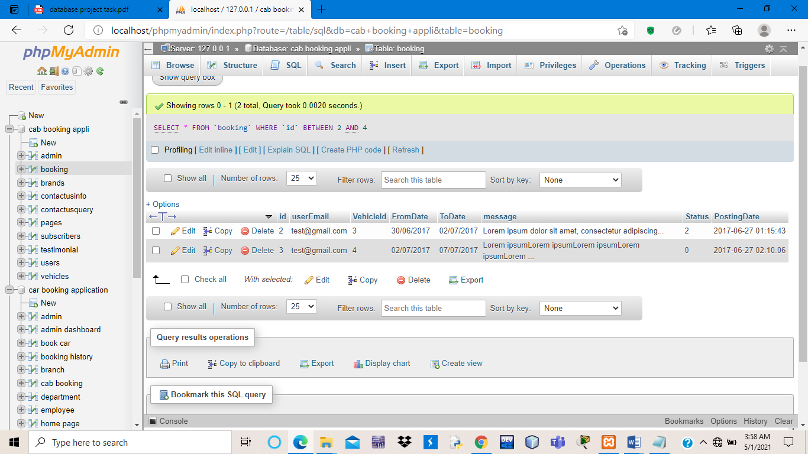

## LIKE

[SELECT](http://localhost:8012/phpmyadmin/url.php?url=https://dev.mysql.com/doc/refman/8.0/en/select.html) `donor_ID`, `bloodGroup` FROM `donor` WHERE `bloodGroup` [like](http://localhost:8012/phpmyadmin/url.php?url=https://dev.mysql.com/doc/refman/8.0/en/string-comparison-functions.html#operator_like) 'A%'

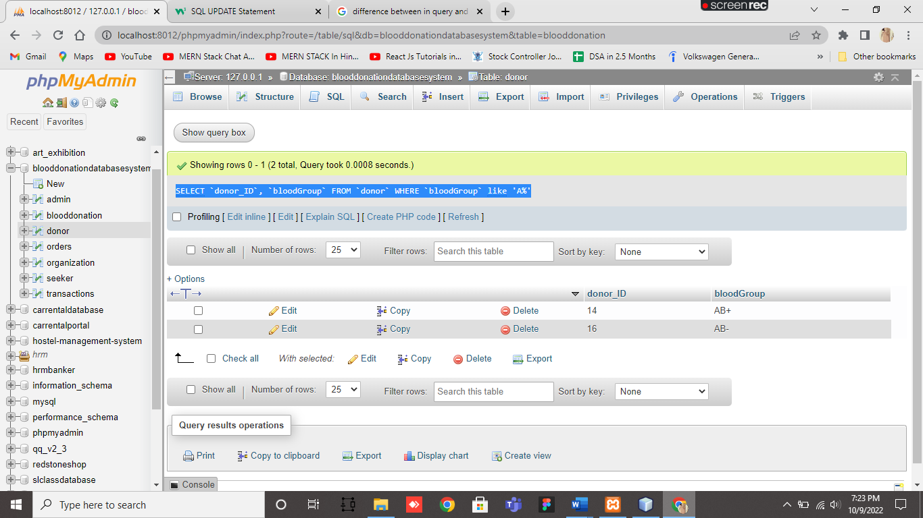

## COUNT, SUM, MIN, MAX

[SELECT](http://localhost/phpmyadmin/url.php?url=https://dev.mysql.com/doc/refman/8.0/en/select.html) [COUNT](http://localhost/phpmyadmin/url.php?url=https://dev.mysql.com/doc/refman/8.0/en/group-by-functions.html#function_count)(*) AS "transactions" FROM transactions

[SELECT](http://localhost/phpmyadmin/url.php?url=https://dev.mysql.com/doc/refman/8.0/en/select.html) [COUNT](http://localhost/phpmyadmin/url.php?url=https://dev.mysql.com/doc/refman/8.0/en/group-by-functions.html#function_count)(*) AS "orders" FROM orders

[SELECT](http://localhost/phpmyadmin/url.php?url=https://dev.mysql.com/doc/refman/8.0/en/select.html) [SUM](http://localhost/phpmyadmin/url.php?url=https://dev.mysql.com/doc/refman/8.0/en/group-by-functions.html#function_sum)(Quantity) AS Total_bloodUnits FROM blooddonation

[SELECT](http://localhost/phpmyadmin/url.php?url=https://dev.mysql.com/doc/refman/8.0/en/select.html) bloodGroup,[MIN](http://localhost/phpmyadmin/url.php?url=https://dev.mysql.com/doc/refman/8.0/en/group-by-functions.html#function_min)(Quantity) AS min_bloodUnits FROM orders

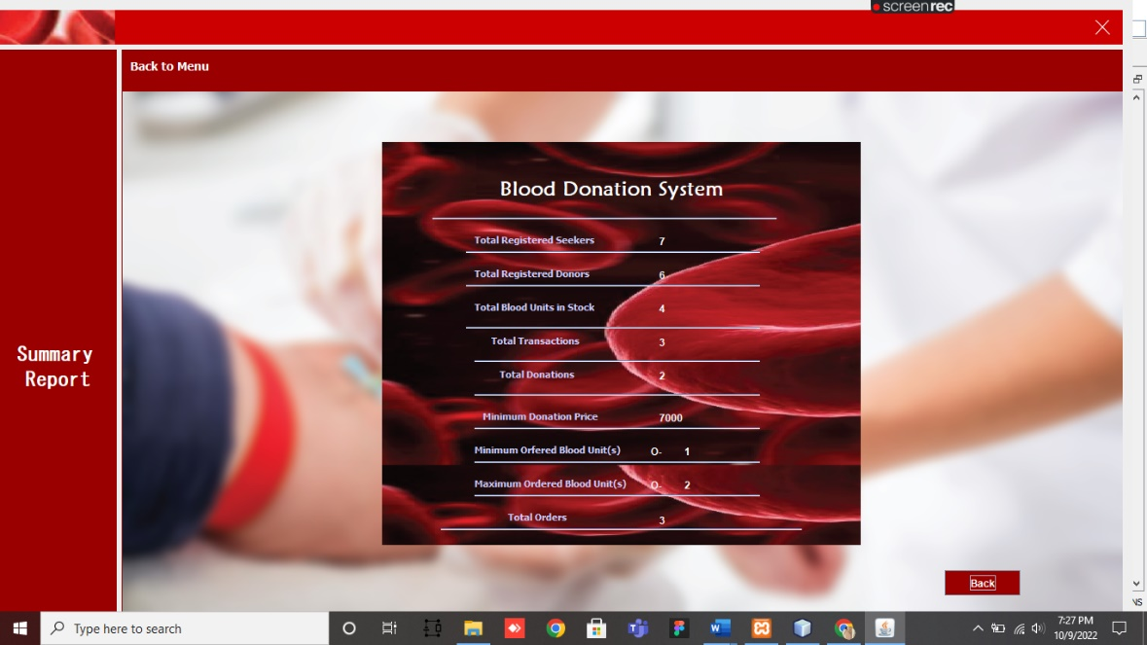 [SELECT](http://localhost/phpmyadmin/url.php?url=https://dev.mysql.com/doc/refman/8.0/en/select.html) bloodGroup,[MAX](http://localhost/phpmyadmin/url.php?url=https://dev.mysql.com/doc/refman/8.0/en/group-by-functions.html#function_max)(Quantity) AS max_bloodUnits FROM orders

## ORDER BY

[SELECT](http://localhost:8012/phpmyadmin/url.php?url=https://dev.mysql.com/doc/refman/8.0/en/select.html) blooddonation.donation_ID,donor.Name,donor.donor_ID,donor.email, blooddonation.bloodGroup,blooddonation.Quantity,blooddonation.price " + "FROM donor [LEFT](http://localhost:8012/phpmyadmin/url.php?url=https://dev.mysql.com/doc/refman/8.0/en/string-functions.html#function_left) JOIN blooddonation ON donor.donor_ID = blooddonation.donor_ID ORDER BY blooddonation.bloodGroup

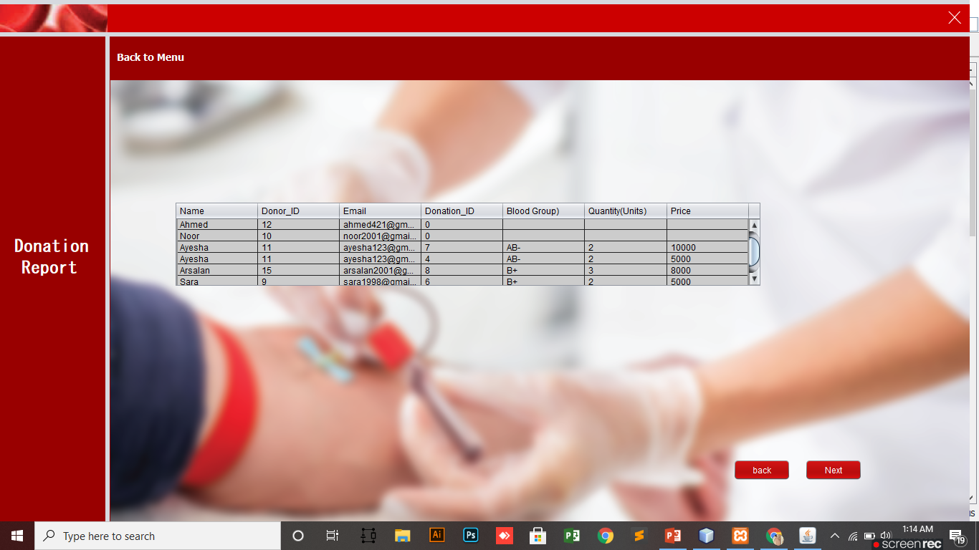

## GROUP BY

[SELECT](http://localhost:8012/phpmyadmin/url.php?url=https://dev.mysql.com/doc/refman/8.0/en/select.html) [COUNT](http://localhost:8012/phpmyadmin/url.php?url=https://dev.mysql.com/doc/refman/8.0/en/group-by-functions.html#function_count)(donor_ID), bloodGroup FROM donor GROUP BY bloodGroup

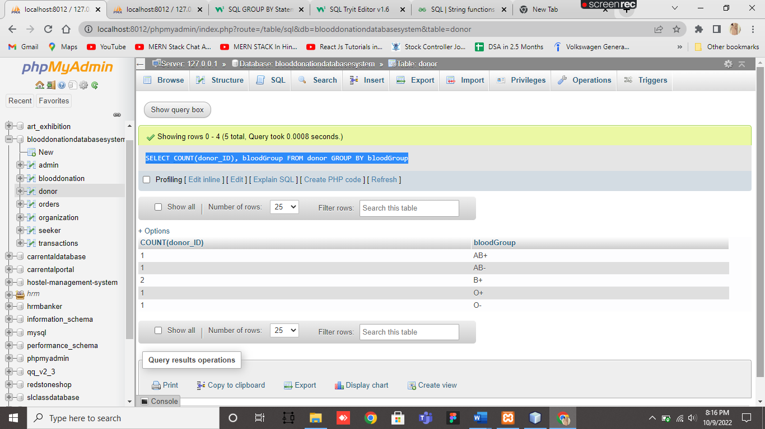

## HAVING

[SELECT](http://localhost:8012/phpmyadmin/url.php?url=https://dev.mysql.com/doc/refman/8.0/en/select.html) [COUNT](http://localhost:8012/phpmyadmin/url.php?url=https://dev.mysql.com/doc/refman/8.0/en/group-by-functions.html#function_count)(donor_ID), bloodGroup FROM donor GROUP BY bloodGroup HAVING [COUNT](http://localhost:8012/phpmyadmin/url.php?url=https://dev.mysql.com/doc/refman/8.0/en/group-by-functions.html#function_count)(donor_ID) > 1

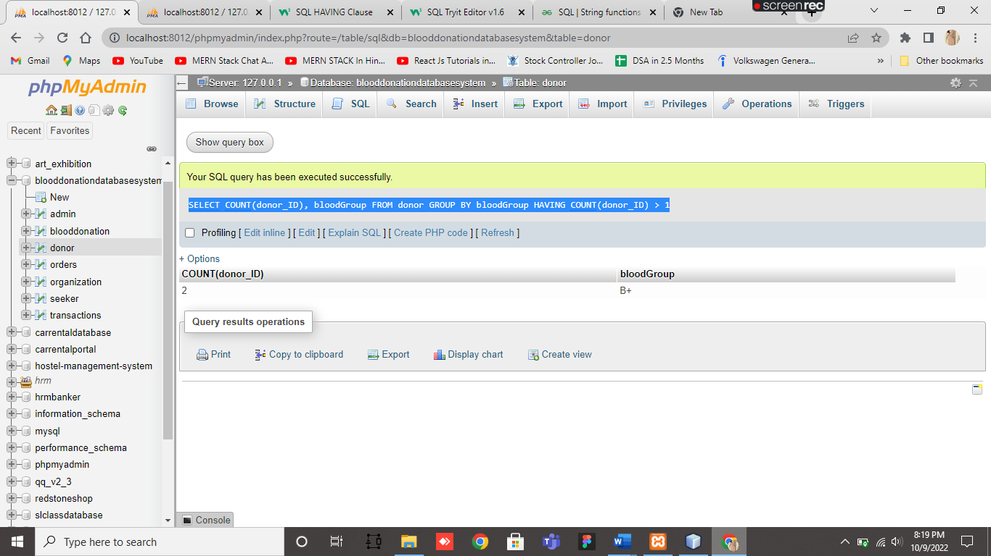

## INNER JOIN

[SELECT](http://localhost/phpmyadmin/url.php?url=https://dev.mysql.com/doc/refman/8.0/en/select.html) d.donor_ID,d.Name,d.phoneNumber,b.bloodGroup,b.price,b.Quantity FROM donor d INNER JOIN blooddonation b ON b.donor_ID=d.donor_ID WHERE d.donor_ID=9

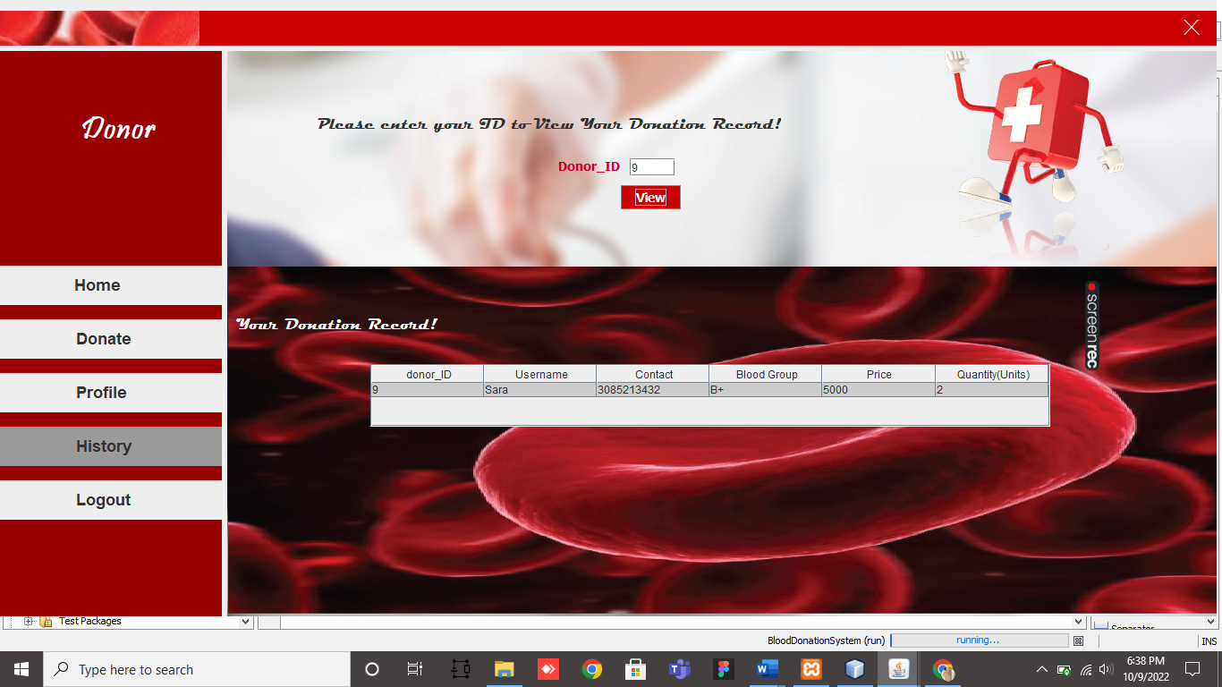

## LEFT JOIN

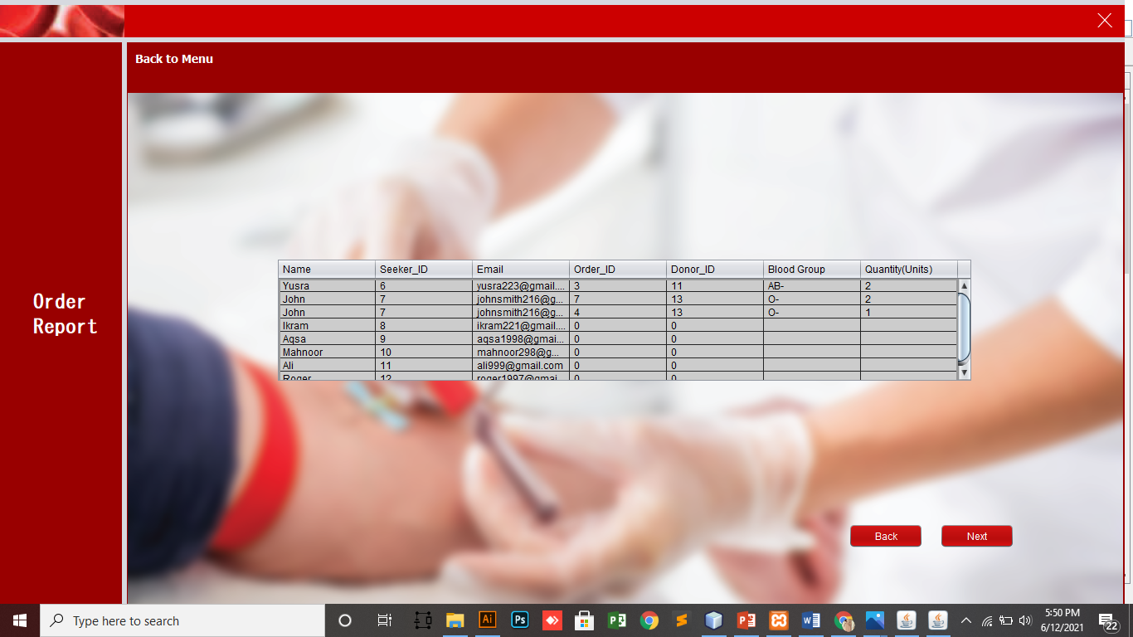[SELECT](http://localhost/phpmyadmin/url.php?url=https://dev.mysql.com/doc/refman/8.0/en/select.html) seeker.Name,seeker.seeker_ID,seeker.email, Orders.order_ID,orders.donor_ID,orders.bloodGroup,orders.Quantity FROM seeker [LEFT](http://localhost/phpmyadmin/url.php?url=https://dev.mysql.com/doc/refman/8.0/en/string-functions.html#function_left) JOIN Orders ON seeker.seeker_ID = Orders.seeker_ID ORDER BY seeker.seeker_ID

### LEFT OUTER JOIN

[SELECT](http://localhost/phpmyadmin/url.php?url=https://dev.mysql.com/doc/refman/8.0/en/select.html) * FROM admin [LEFT](http://localhost/phpmyadmin/url.php?url=https://dev.mysql.com/doc/refman/8.0/en/string-functions.html#function_left) OUTER JOIN book_cab ON (admin.id = book_cab.id)

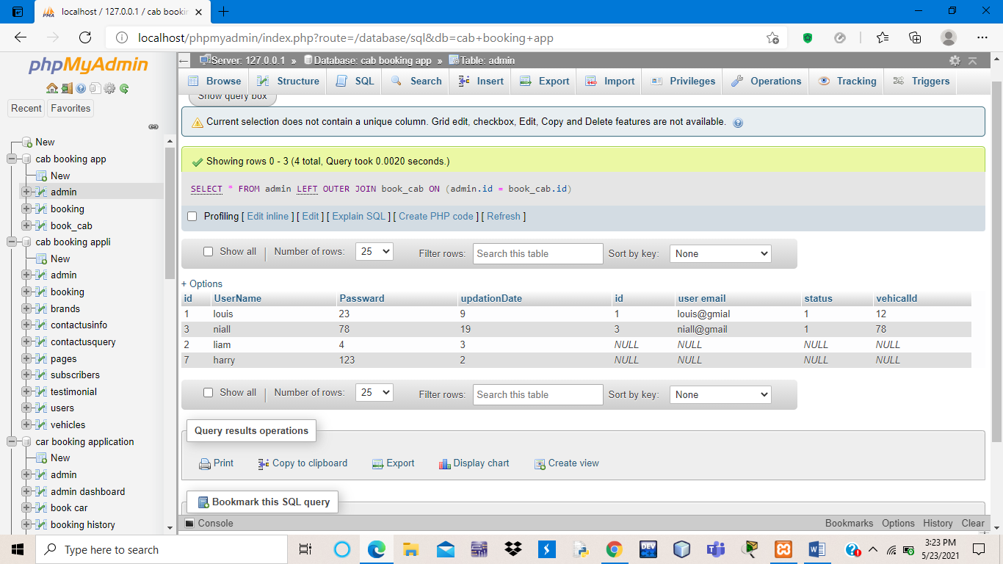

### RIGHT OUTER JOIN

[SELECT](http://localhost/phpmyadmin/url.php?url=https://dev.mysql.com/doc/refman/8.0/en/select.html) * FROM admin [RIGHT](http://localhost/phpmyadmin/url.php?url=https://dev.mysql.com/doc/refman/8.0/en/string-functions.html#function_right) OUTER JOIN book_cab ON (admin.id = book_cab.id)

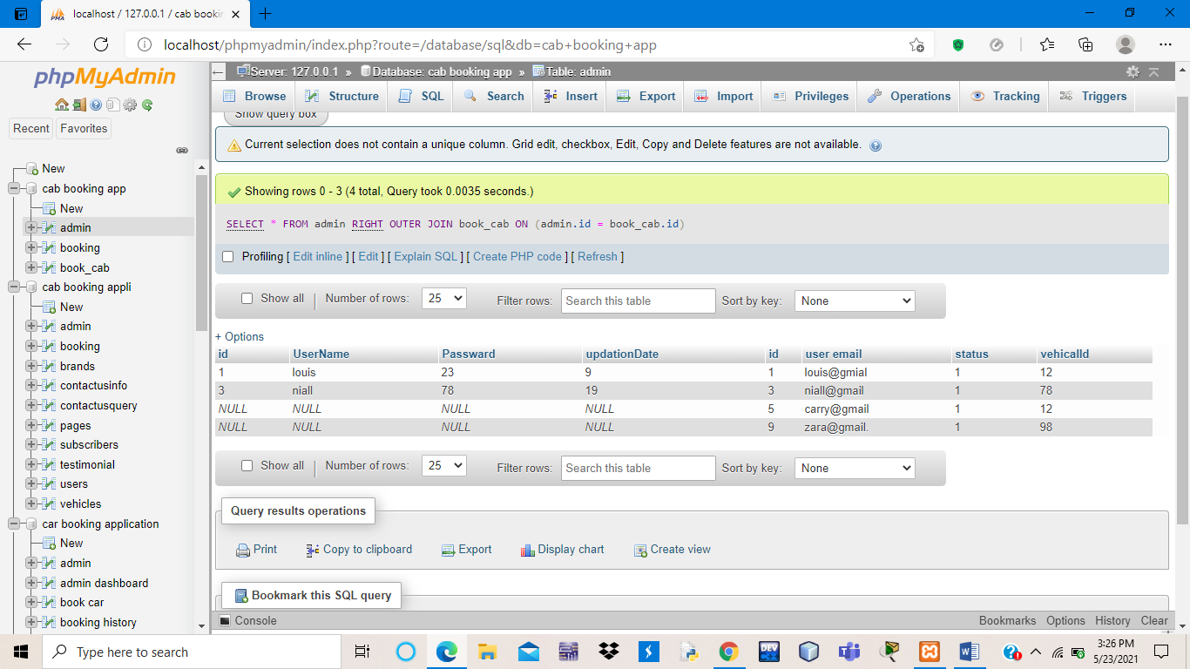

## SELF JOIN

[SELECT](http://localhost:8012/phpmyadmin/url.php?url=https://dev.mysql.com/doc/refman/8.0/en/select.html) d.bloodGroup FROM donor d, donor d2 WHERE d2.bloodGroup='AB+'

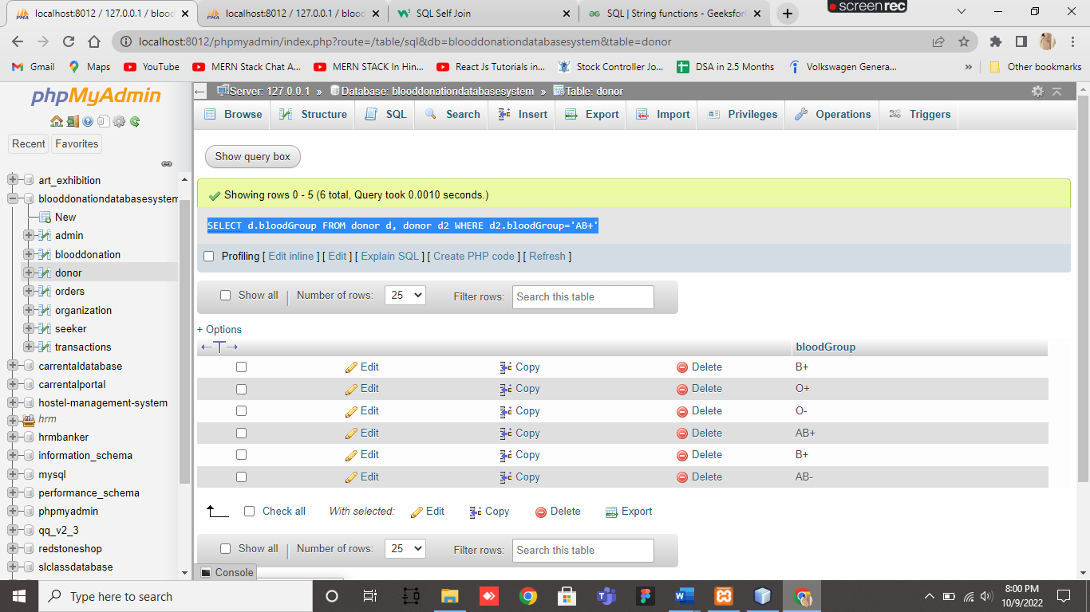

## CREATE VIEW

[CREATE](http://localhost:8012/phpmyadmin/url.php?url=https://dev.mysql.com/doc/refman/8.0/en/create-view.html) [VIEW](http://localhost:8012/phpmyadmin/url.php?url=https://dev.mysql.com/doc/refman/8.0/en/create-view.html) BGroupDonors AS [SELECT](http://localhost:8012/phpmyadmin/url.php?url=https://dev.mysql.com/doc/refman/8.0/en/select.html) Name, donor_ID FROM donor WHERE bloodGroup = 'B+' [OR](http://localhost:8012/phpmyadmin/url.php?url=https://dev.mysql.com/doc/refman/8.0/en/logical-operators.html#operator_or) bloodGroup = 'B-'

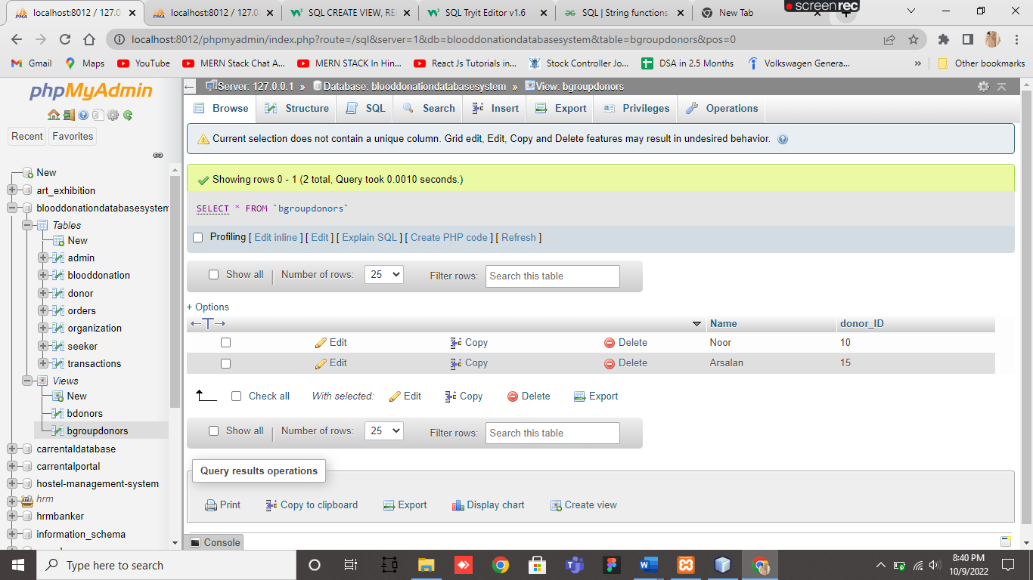

## AVG

[SELECT](http://localhost:8012/phpmyadmin/url.php?url=https://dev.mysql.com/doc/refman/8.0/en/select.html) [AVG](http://localhost:8012/phpmyadmin/url.php?url=https://dev.mysql.com/doc/refman/8.0/en/group-by-functions.html#function_avg)(`price`) FROM blooddonation

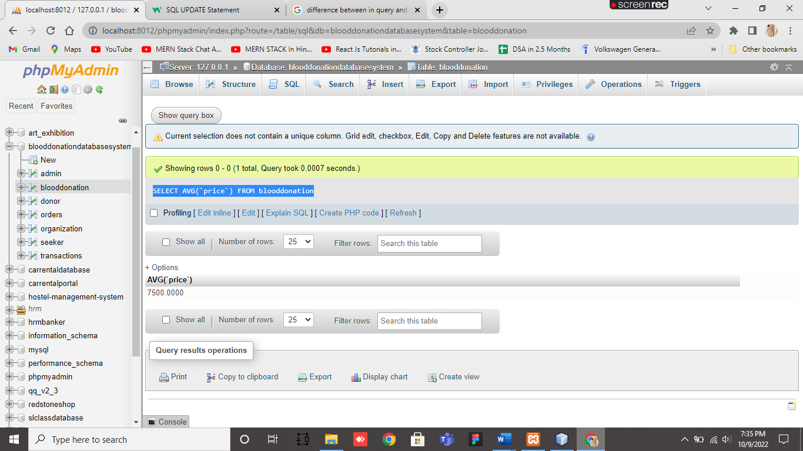

## SQL STRING FUNCTIONS

[SELECT](http://localhost:8012/phpmyadmin/url.php?url=https://dev.mysql.com/doc/refman/8.0/en/select.html) [LEFT](http://localhost:8012/phpmyadmin/url.php?url=https://dev.mysql.com/doc/refman/8.0/en/string-functions.html#function_left)(Name, 5) FROM donor

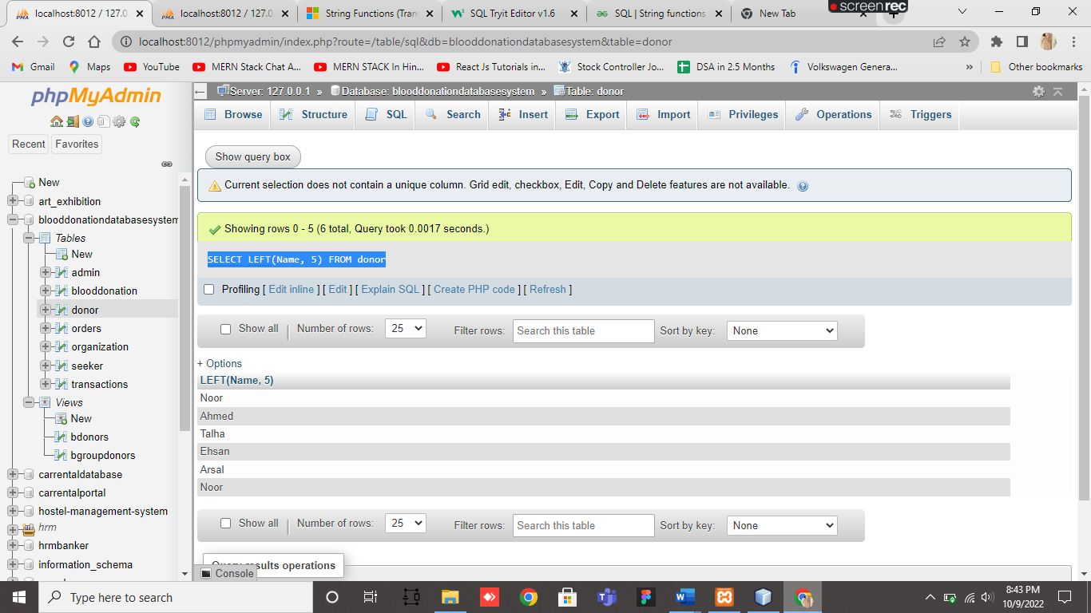

[SELECT](http://localhost:8012/phpmyadmin/url.php?url=https://dev.mysql.com/doc/refman/8.0/en/select.html) UPPER(Name) FROM donor

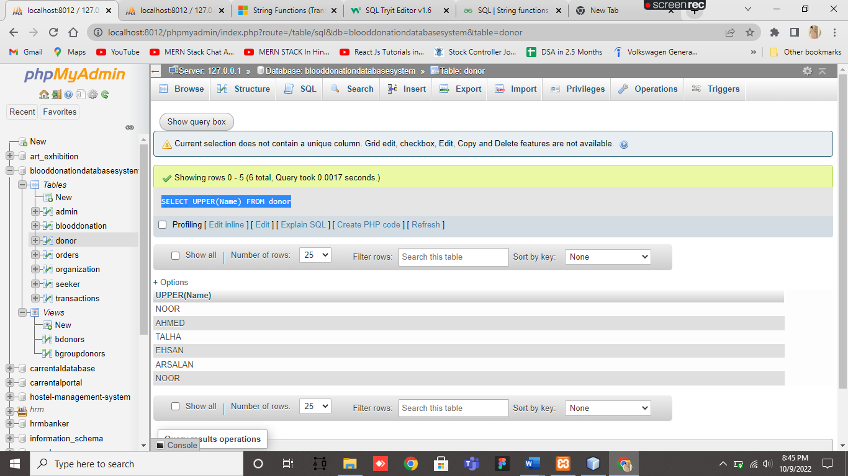

[SELECT](http://localhost:8012/phpmyadmin/url.php?url=https://dev.mysql.com/doc/refman/8.0/en/select.html) CONCAT ( Name, bloodGroup ) AS Result FROM donor

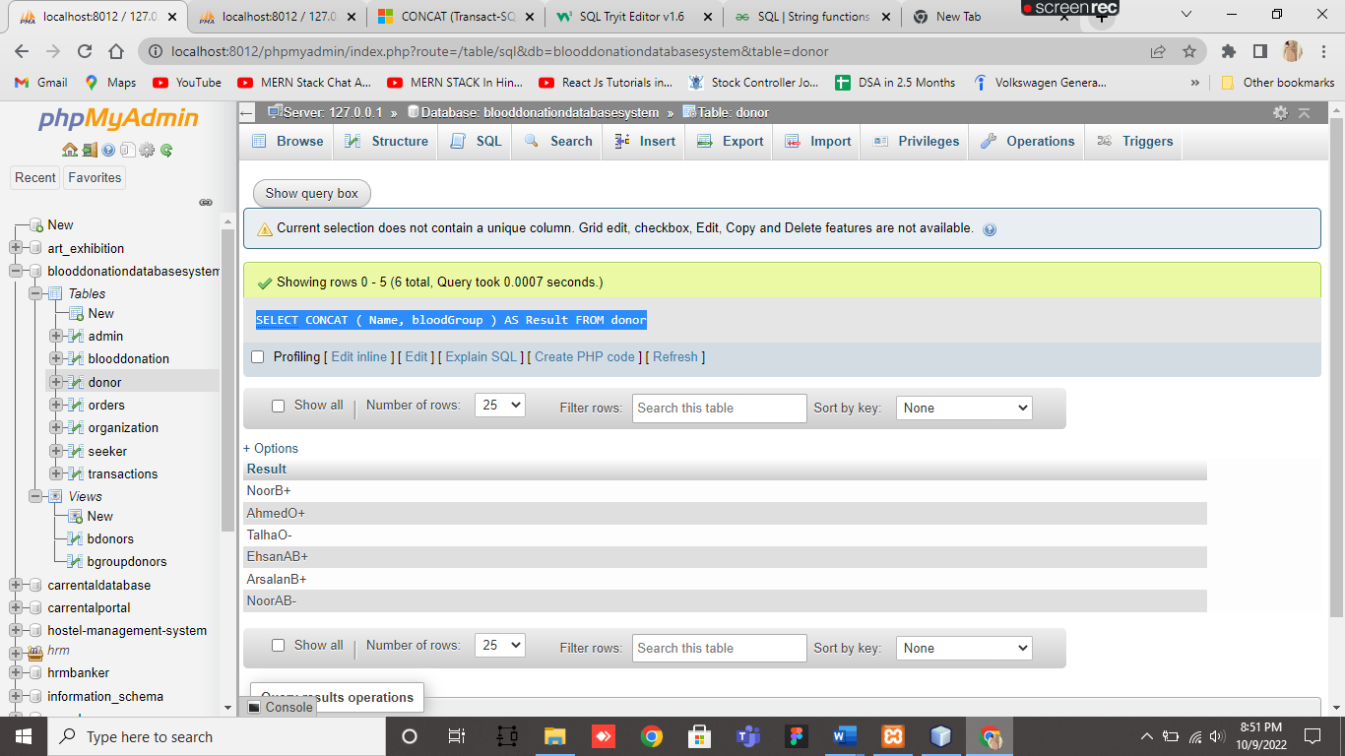

## SQL UNION

[SELECT](http://localhost:8012/phpmyadmin/url.php?url=https://dev.mysql.com/doc/refman/8.0/en/select.html) * FROM donor [LEFT](http://localhost:8012/phpmyadmin/url.php?url=https://dev.mysql.com/doc/refman/8.0/en/string-functions.html#function_left) JOIN blooddonation ON donor.donor_ID = blooddonation.donor_ID UNION [SELECT](http://localhost:8012/phpmyadmin/url.php?url=https://dev.mysql.com/doc/refman/8.0/en/select.html) * FROM donor [RIGHT](http://localhost:8012/phpmyadmin/url.php?url=https://dev.mysql.com/doc/refman/8.0/en/string-functions.html#function_right) JOIN blooddonation ON donor.donor_ID = blooddonation.donor_ID



